SAMPLE QUESTION PAPER 2
MULTIMEDIA & WEB TECHNOLOGIES (Code 067)

Class XII
Max. Marks : 70 Duration : 3 hrs.

1. | a) | What is the role of primary key in a database? | 1
 | b) | What is the difference between the Number and Auto Number datatypes of Access? | 1
 | c) | Study the following data and answer the questions given below:  Table: Book  Table: Issue  - Name the fields, which can act as the primary key and foreign key for the table Book and the table Issue respectively.  - What type of relationship exists between table Book and table Issue? | 2  1
  Book_Title | Acc_no | Author | Price
  ASP | 1002 | Russell | 325.00
  VBScript | 1014 | Simon | 295.00
  HTML | 1001 | Ray | 350.00
  Jscript | 1020 | Jaworski | 375.00
  Member_no | Issue_Date | Return_Date | Acc_No
  1432 | 07/12/2003 | 07/22/2003 | 1001
  2042 | 09/30/2003 | 10/10/2003 | 1020
  1245 | 10/08/2003 | 10/18/2003 | 1002
  1432 | 10/03/2003 | 10/13/2003 | 1014
  1324 | 09/30/2003 | 10/03/2003 | 1001
  1565 | 04/05/2003 | 04/26/2003 | 1020
 | d) | What is the full form of PNG? | 1
 | e) | Name any two file formats, which can be used, for storing movie files. | 2
 | f) | Differentiate between the .FLA and .SWF file formats of a Flash movie. | 2
2. |  | Answer the following questions based on Macromedia Flash:
 | a) | Define the term Framerate. | 1
 | b) | Write the difference between a guide layer and a mask layer. | 2
 | c) | Differentiate between a Symbol and an Instance. | 2
 | d) | What is the difference between hiding a frame and locking a frame? | 1
 | e) | Consider the figure given below and do as directed:  - The circle on the left hand side shows the position and size of the image for frame 1. The colour of the image is red.  - The circle on the right hand side shows the position and size of the image for frame 20. The colour of the image is yellow.  Write the procedure and property settings for animating the above scenario. | 4
3. |  | Answer the following questions based on HTML:
 | a) | What is the difference between the <FRAME> and <FRAMESET> tags? | 1
 | b) | Specify the tag and attributes to create a TextArea with 5 rows and 20 columns. | 1
 | c) | Write the HTML code to generate a Web Page in the format given below : | 8

Consider the following while writing the HTML code
- Title of the page should be “Hospiatality Industry”
- Background colour of the page should be “Silver”, Link colour should be “Maroon”, visited link colour should be “Red” .
- Picture used in the page is the file “beach.jpg”
- Table should have a border of width 2.
- Use the concept of nested lists for creating the list given in the web page with specified bullets.
- Pages linked to :
  - Front Office as “front.html”
  - Food & Beverages as “food.html”

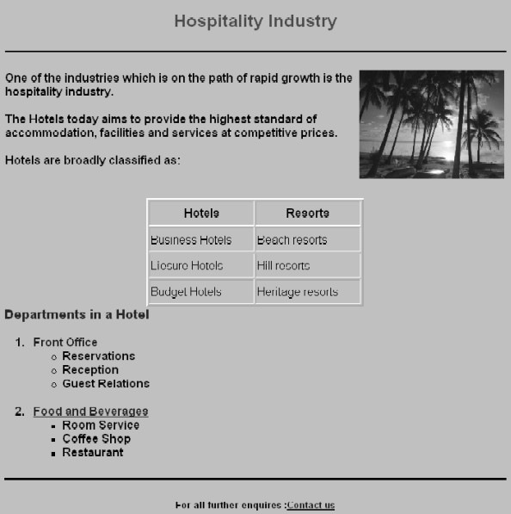

4. |  | Answer the following questions based on ASP:
 | a) | Name any two technologies which are equivalent to ASP. | 1
 | b) | Define variant datatype. Name any two sub-types of the variant datatype. | 2
 | c) | Explain with an example the difference between the string operators + and &. | 2
 | d) | Give the usage and syntax of the following in-built functions:  (i) ABS( ) (ii) CDate( ) | 2
 | e) | Give output of the following statements:  - Response.Write(UCASE(MID("Hello There"),7,3)))  - Response.Write(MONTHNAME(MONTH("15-2-2003")))  - Response.Write((4+5)MOD(3^2)) | 3
5. |  | Answer the following questions based on ASP:
 | a) | What is the purpose of using the Global.asa file? | 1
 | b) | Differentiate between the RESPONSE object and REQUEST object . | 2
 | c) | Rewrite the following code after removing errors with each correction underlined.  <HTML>  <HEAD>  <%  sub vbproc(num1,num2)  request.write(num1*num2)  %>  </HEAD>  <BODY>  <p>  Result: <%call vbproc(3)%>  </p>  <%vbproc 3,4>  </p>  </body>  </html> | 2
 | d) | Give the output for the following code segment:  <html>  <body>  <%  sometext = "Bye!"  max=Len(sometext)  For i=0 to max  newtext=Left(sometext,i)  response.write(strReverse(newtext))  response.write("<br>")  next  %> | 2
 | e) | Maxima International is a company that provides software solutions to their clients. The company wishes to design an ASP coded web page with the following specifications:  - To display the current time and the name of the company on the opening page as displayed  - To display a greeting message “GOOD MORNING” if the user accesses the website between 5 and 12 A.M. and “GOOD EVENING” otherwise.  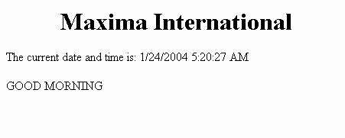 | 3
6. |  | Answer the following questions based on VBScript:
 | a) | Differentiate between a sub-routine and a function with the help of an example. | 2
 | b) | Write the equivalent script for the following code using FOR loop without effecting the output:  <SCRIPT LANGUAGE="VBScript">  DIM count,ans  ans=1  count=2  DO  ans=ans*count  count=count+2  LOOP WHILE count<=10  document.write(ans)  </SCRIPT> | 2
 | c) | Give the output of the following code segment:  <SCRIPT LANGUAGE="VBScript">  Dim Names()  Dim Count  Count = 2  ReDim Names(Count)  Names(0)="Raj"  Names(1)="Simran"  Names(2)="Nisha"  ReDim Names(Count + 2)  Names(3)="Maya"  Names(4)="Rohit"  Document.Write(Names(0))  Document.Write(Names(1))  Document.Write(Names(2))  Document.Write(Names(3))  Document.Write(Names(4))  </SCRIPT> | 2
 | d) | Create a form that contains two checkbox options and a textbox as shown below. When the user clicks on any checkbox the selected options must be displayed in the textbox. Write the HTML code for creating the form and the embedded VBScript code for the click events of the checkboxes.  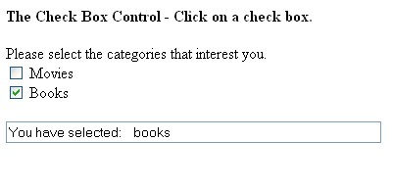 | 4
7. |  | Answer the following questions based on Communication and network concepts:
 | a) | What is INTERSPACE? | 1
 | b) | Differentiate between twisted pair cable and coaxial cable. | 2
 | c) | Explain the following terms:  - Shareware  - GSM  - TCP/IP | 3
 | d) | An Organization has its offices in building A, B, C and D. Answer questions (a) to (d) in context of the following layout of the three offices:  A  B  C  D  Centre to Centre distances between different buildings are as follows:  Each of the above buildings has following number of computers | 4
  Block A to Block B | 100 m
  Block A to Block C | 70 m
  Block A to Block D | 20 m
  Block B to Block C | 150 m
  Block B to Block D | 120 m
  Block C to Block D | 140 m
  A | 65
  B | 30
  C | 25
  D | 40
 | (i) | Suggest and draw the layout for a network, with proper justification to connect all the office
 | (ii) | Where would the following preferably be placed  - Bridge  - Repeater
 | (iii) | Suggest the most suitable place to house the server for the organization with proper justification.
 | (iv) | If the organization needs to link up to a branch office which is in a neighboring city, (around 100 km distant) suggest the best type of cabling connection, from the building hosting the server, provided price is not a factor.

